**Data-Dependent-Assisted Data-Independent Acquisition (DaDIA.R) User Manual**

（Version 2, 2021-01-04）

Jian Guo1, Sam Shen1, Shipei Xing1, Tao Huan1,*

1 Department of Chemistry, Faculty of Science, University of British Columbia, Vancouver Campus, 2036 Main Mall, Vancouver, V6T 1Z1, BC, Canada

* Author to whom correspondence should be addressed:

Dr. Tao Huan

Tel: (+1)-604-822-4891

E-mail: [thuan@chem.ubc.ca](mailto:thuan@chem.ubc.ca)

Internet: <https://huan.chem.ubc.ca/>

* DaDIA.R is an R script for performing DaDIA workflow of metabolic feature extraction and annotation.
* The program is written in the language ‘R’ and is publicly available at https://github.com/HuanLab/DaDIA.git
* Please see below for detailed instructions on using the DaDIA.R code:

1. **File preparation.** (**Important: the number of samples in line 38 has to agree with the real number of DIA mzXML files**). User needs to create two folders to store DDA and DIA files separately. All mzXML files from DDA analyses need to be put in the DDA folder. All mzXML files from DIA analyses need to be put in the DIA folder. The library file in the format of .msp should also be put in the DIA folder. In addition, a .txt file containing the information about the DIA *m/z* range should also be put into the DIA folder. **Figure 1** illustrates the details of how the files should be organized in the corresponding folders. The values in the .txt file are separated by tab. If it is DIA(SWATH) data, the txt file should contain the information about the *m/z* range for the survey scan and SWATH windows. If it is DIA(AIF) data, the txt file should contain the information about the *m/z* range for the survey scan and AIF window. The *m/z* range file examples for both DIA(SWATH) and DIA(AIF) are illustrated in **Figure 2**. Note that the column headers should be kept the same as the examples shown.

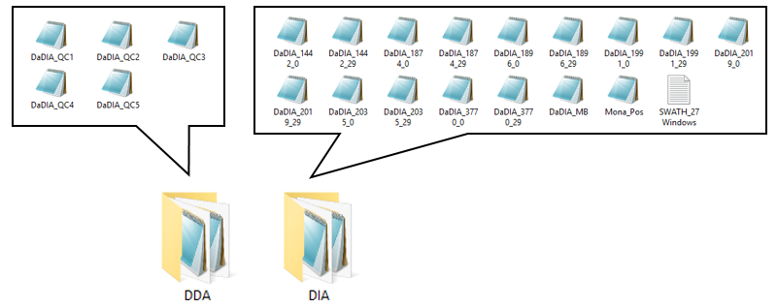

**Figure 1.** *m/z* range file sample format for DIA(SWATH) (left) and DIA(AIF) (right) files.

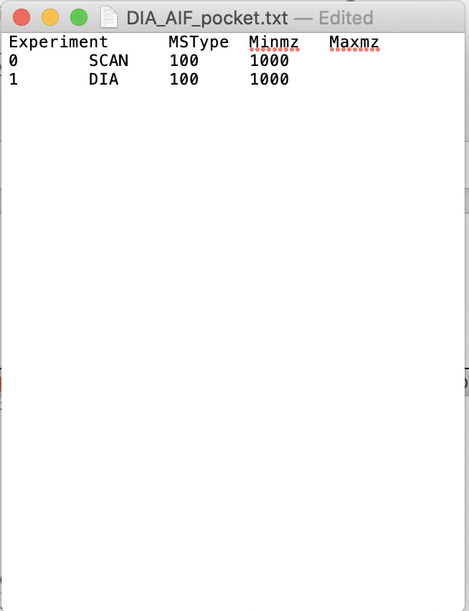

**Figure 2.** *m/z* range file sample format for DIA(SWATH) (left) and DIA(AIF) (right) files.

1. Download the R-scrip “DaDIA.R” from Github (https://github.com/HuanLab/DaDIA.git).

**R package installation.** In R-studio, user needs to first install libraries “xcms”, “MSnbase”, “dplyr”, “doParallel”, “foreach”, “metaMS”, and “CAMERA” if they are previously not installed. **R Version 4.0 or above, XCMS Development Version 3.11.4 or above, and metaMS Version 1.25.1 are required; all other packages should be updated to the newest available version**.

1. **Parameter setting.** After all the required libraries are successfully installed. User needs to set the parameters to their desired values. All the parameters available for customized setting are in line 17 – 60, as shown in **Figure 3**. The function of each parameter is described in **Table 1**.

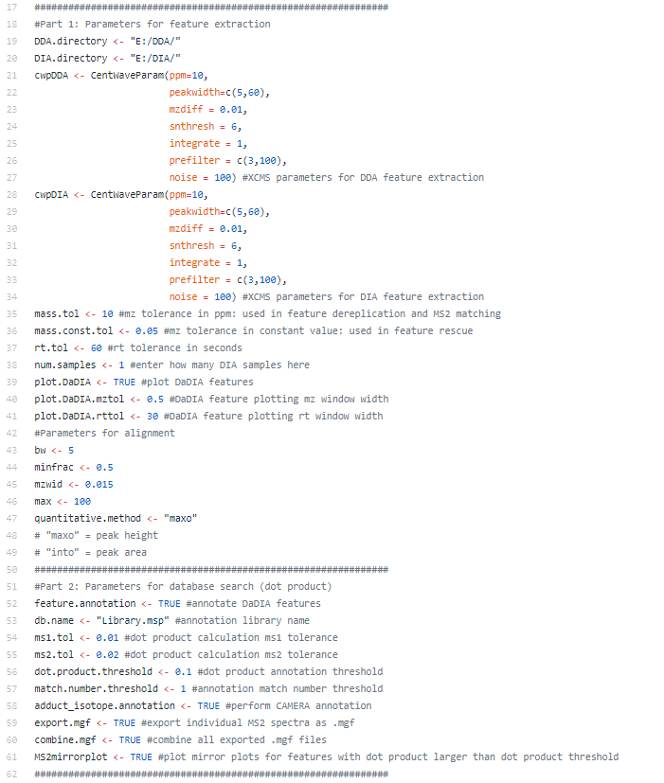

**Figure 3.** Parameter settings of DaDIA.R.

**Table 1.** The functions of all DaDIA parameters.

|  |  |  |
| --- | --- | --- |
| **Line #** | **Parameter Name** | **Parameter Function** |
| 19 | *DDA.directory* | Set the directory containing all DDA .mzxml files |
| 20 | *DIA.directory* | Set the directory containing all DIA .mzxml files, *m/z* window .txt file (no specific name is required as the program recognizes it by its file type), and annotation library .msp file |
| 21 | *cwpDDA* | Set XCMS parameters for DDA feature extraction |
| 28 | *cwpDIA* | Set XCMS parameters for DIA feature extraction |
| 35 | *mass.tol* | Set *m/z* tolerance (± ppm) for MS1 feature dereplication and MS2 matching |
| 36 | *mass.const.tol* | Set *m/z* tolerance (± constant value) for rescuing DIA features using DDA data |
| 37 | *rt.tol* | Set retention time tolerance (± sec) for identifying the same features |
| 38 | *num.samples* | Set number of DIA samples to run |
| 39 | *plot.DaDIA* | Set whether to plot EIC for DaDIA features |
| 40 | *plot.DaDIA.mztol* | Set *m/z* window width for DaDIA feature EIC plotting |
| 41 | *plot.DaDIA.rttol* | Set RT window width for DaDIA feature EIC plotting |
| 43 | *bw* | Set XCMS feature alignment bandwidth |
| 44 | *minfrac* | Set XCMS feature alignment minimum sample fraction |
| 45 | *mzwid* | Set XCMS feature alignment *m/z* slice width |
| 46 | *max* | Set XCMS feature alignment maximum # of groups / slice |
| 47 | *quantitative.method* | Set whether to use peak height or peak area for quantitative calculations |
| 52 | *feature.annotation* | Set whether to perform MS2 extraction and DaDIA feature annotation |
| 53 | *db.name* | Set the name of the library used for metabolite annotation |
| 54 | *ms1.tol* | Set MS1 tolerance in dot product calculation for metabolite annotation |
| 55 | *ms2.tol* | Set MS2 tolerance in dot product calculation for metabolite annotation |
| 56 | *dot.product.threshold* | Set annotation dot product score threshold |
| 57 | *match.number.threshold* | Set annotation match number threshold |
| 58 | *adduct_isotope.annotation* | Set whether to perform CAMERA adduct and isotope annotation |
| 59 | *export.mgf* | Set whether to export MS2 spectra as individual .mgf files |
| 60 | *combine.mgf* | Set whether to concatenate all exported .mgf files into a single .mgf file |
| 61 | *MS2mirrorplot* | Set whether to plot MS2 mirror plot |

1. Note: user needs to set the directory in the user’s computer that contains all DDA samples in line 18. User needs to set the directory in the user’s computer that contains all DIA samples, *m/z* range definitions in .txt format (for DIA(SWATH) or DIA(AIF)), and the annotation library in .msp format in line 19. If you want the waning messages to show, change the options in line 7 from -1 to 0.
2. In R-studio, click on “🡪Source” in the top right corner of the R-studio interface to begin the DaDIA data processing.
3. After running the scrip for single DDA and single DIA sample, one csv file “DaDIAtable.csv” containing all metabolic features extracted and one csv file “annotated_output.csv” containing all feature annotation results will be generated in the DIA folder. After running the scrip for multiple DDA and DIA samples, multiple csv files “n_DaDIAtable.csv” (n is the number of DIA samples) containing all metabolic features extracted for each sample, one csv file “alignedDaDIAtable.csv” containing aligned features, and one csv file “annotated_output.csv” containing the annotation results for the aligned features will be generated in the DIA folder.
4. Notably, in “annotated_output.csv” file, the columns with the header “MS2-Available” contains either TRUE or FALSE values. TRUE means there are MS2 spectra assigned to the features, while FALSE means there are no MS2 spectra assigned. If the user performs “CAMERA”, there will be three additional columns shown up in the file showing the isotopic, adduct, and pcgroup information. The features with the same number in “pcgroup” are actually the same metabolite as they are highly correlated peaks.

**Specific Notes**

1. Note: if users wish to use their own in-house library in .csv format for annotation, they must first convert their library from .csv file to an .msp file using the R script *“*convertMSP.R*”* at the provided website on GitHub (https://github.com/HuanLab/DaDIA.git).
2. Note: user can choose to plot the EIC of all the metabolic features by switching on the plot function in line 38 and setting the *m/z* and retention time tolerance in line 39, 40. If the user chooses to plot DaDIA features, a folder named “DaDIA_EIC” will be generated in the DIA folder containing all the EIC plots. The name of the EIC plots is composed of feature retention time and *m/z* values.
3. Note: user can choose to output individual .mgf files for each feature by switching on the function in line 58. Two folders named “DDAmgf” and “DIAmgf” will be generated in the DIA folder containing all individual mgf files from either DDA or DIA data. If the user wishes to output one additional mgf file combining all the MS2 information into one file, they can switch on the function in line 59. An mgf file named “combined_mgf” will be generated in the DIA folder. The names of all the mgf files are composed of precursor mass, retention time and the source of the MS2 spectrum. (whether it is from DDA or DIA data)
4. Note: user can choose to generate the MS2 mirror plot by switching on the function in line 60. A folder named “MS2mirrorplot” will be generated in the DIA folder containing all the mirror plots in .png file for the features with dot products larger than dot product threshold set by user. In each mirror plot, the corresponding metabolite name is shown on the top of the plot. The name of each plot file is composed of the feature ID and the dot product of the feature.